Running Your Own ‘Digital Collection Day’
An Introductory Guide

This short guide is designed to introduce you and your organization to the basic elements of organising and planning a ‘Digital Collection Day’. It includes:

- A brief description of the History and Mission of Oxford University’s ‘Lest We Forget’ project
- An outline of what ‘A Digital Collection Day’ is, what its aims are, and what it requires
- A basic Planning Guide, outlining the format of the event, its staff, equipment, and promotion, etc.

If, after reading this Introductory Guide, you and your organisation would like further information on how to run your own ‘Digital Collection Day’, and/or would like to begin the process, please contact the Lest We Forget Team via website: https://lwf.web.ox.ac.uk via email: ww1collections@it.ox.ac.uk or via Facebook: www.facebook.com/OxfordLWF/
We will be delighted to provide you with:
- A detailed ‘TRAINING PACK’, including all the information you need to run a ‘Digital Collection Day’
- Tailored advice, creative ideas, and ongoing support for running your own fantastic event

We Look Forward to Hearing From You

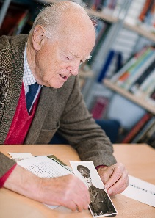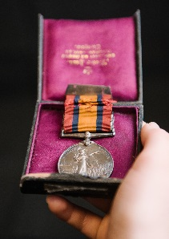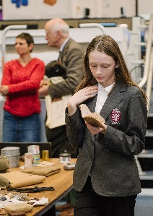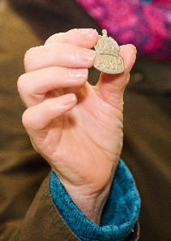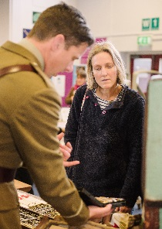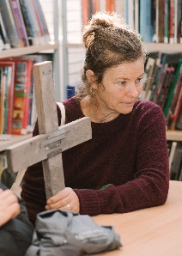

The Lest We Forget Team would like to sincerely THANK YOU for your interest in organizing a ‘Digital Collection Day’. With your help, we can save the memories, stories, and objects of the First World War for future generations.

Short Guide to Lest We Forget

History
Launched in October 2017, following the success of an enormously popular crowdfunding campaign, Lest We Forget (LWF) is an Oxford University led project that aims to capture the memories and stories of the Great War before they are lost to history. The Lest We Forget team is running a unique, large-scale digitisation project that will collect and make publicly available, in digital form, memorabilia and personal accounts of war-time experience. As part of this initiative, LWF helps local communities across the UK to organise and run their own Digital Collection Days in order to gather personal stories of World War One told through photographs, diaries, letters, mementos, and the memories and oral histories passed down through families.

Mission
In November 2018, to complement projects and events nationwide commemorating the centenary of the end of the war, these stories will be made available to the public through a large, free-to-use online database. The database and its contents will be freely accessible, both on the Lest We Forget website, https://lwf.web.ox.ac.uk and on Europeana 1914-1918, bringing these stories and experiences from the past to researchers and educators today.

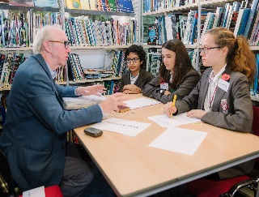
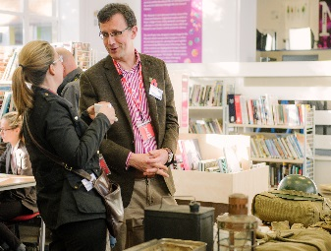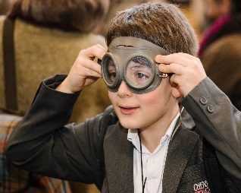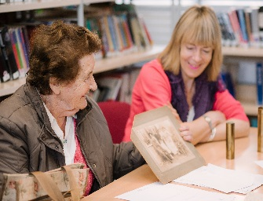

What is a Digital Collection Day?

Introduction
A ‘Digital Collection Day’ is an event where members of the public are invited to bring in their First World War memorabilia and stories. Project staff is on hand to record the stories and digitise any objects. The stories and objects are then uploaded to the Lest We Forget website, https://lwf.web.ox.ac.uk/home, where they are available to anyone who wants to see them.
You can see a short video on what a Digital Collection Day looks like/entails here:
http://podcasts.ox.ac.uk/what-roadshow

The aim of a Digital Collection Day is to:
- help participants share their stories and objects;
- draw attention to the Lest We Forget project and collection;
- encourage online contributions;
- encourage re-use of the collected material;
- promote the local host organisation and/or venue;
- preserve important heritage under threat of disappearing.

What happens at a Digital Collection Day?
Each Digital Collection Day will be unique, since visitors will bring their individual, personal stories and objects. Generally, however, a Digital Collection Day is a large-scale, public one-day event. The normal process at a Digital Collection Day is:
- Visitor arrives and is introduced to the process for contributing;
- Visitor speaks to an interviewer, who records the story and information about any objects that have been brought;
- The objects are digitised (photographed or scanned) and then returned to the visitor;
- The story, object information and digital images are uploaded to the website.

What do I need to hold a Digital Collection Day?
Anyone can run a Digital Collection Day. You will need a venue, some equipment, and staff. The number of staff and size of the venue depend on the format of the event, expected number of visitors, and available resources.
You also need somewhere to put your collected stories and digital images. Lest We Forget has a dedicated website that can be used by those contributing to the project. For more information about planning a Digital Collection Day, see the ‘Planning’ guide, available at https://lwf.web.ox.ac.uk/home.

Available support
If you are interested in organising a Digital Collection Day, please contact the Lest We Forget team at ww1collections@it.ox.ac.uk. We will provide you with our more detailed ‘Training Pack’, along with any additional support and advice you may require. We can also help promote your organization’s Digital Collection Day.

Planning for a Digital Collection Day
This document outlines some of the issues you need to consider when planning a Digital Collection Day. It assumes that material will be published online and that contributors can also contribute digitally (through the website, via email or some other way).
Contents
Format of event 3
Choosing a venue 5
Date and time 6
Staffing 7
Equipment 9
Digitisation equipment: 10
Equipment for interviews 10
Additional equipment 10
Promoting 10
After the event 11
Uploading stories and images 11
Dealing with enquires 11

Format of event
The aim of the Digital Collection Day is to collect material held by the public, digitise it, and then archive and publish it online. The event can also be effective for drawing attention to a project or organisation. The standard process is outlined below:

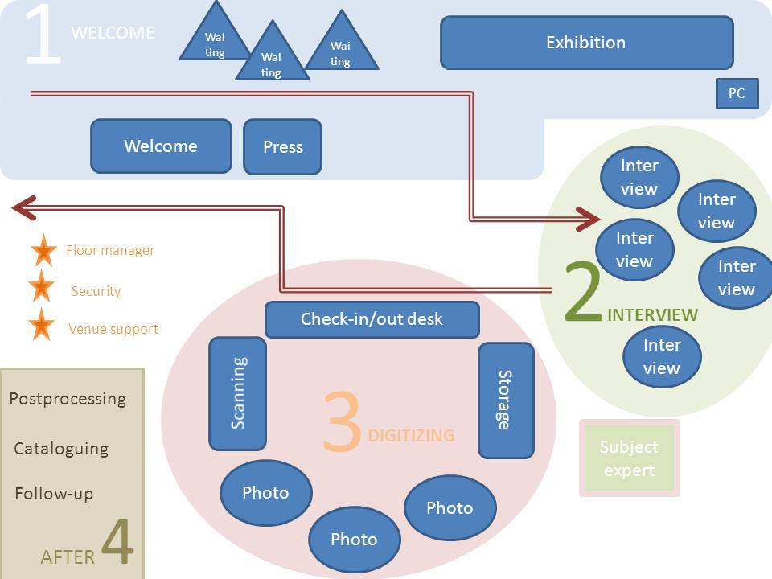

- Visitor arrives – goes to Welcome desk or Press desk (1);
- Visitor is taken to Interview;
- Interviewer records story and object information (2);
- Objects are taken to digitisation;
- Objects are digitised (3);
- Objects are returned and visitor leaves (4);
- Digital images are post-processed (cropped, enhanced, compressed) ;
- Story and object information is finalised and image files added (on website).

A Digital Collection Day does not have to be a one-day event: you could run the event over several days, or collect stories and material over a longer period, as part of the regular activities of the museums, as a school activity, or as a service available by appointment. You can also run your collection with a combination of events, for example a big one-day event followed by shorter sessions once a week or a support service to help contributors add their material to the website.

Choosing a venue
Where you choose to hold your event is important. People are more likely to come to an event at a place which they can access easily (in a central location or with good public transport links), where there are other facilities nearby which they visit anyway (shops or museums), or somewhere which they may not otherwise be able to see (normally closed to the public). Remember that although hosting a Digital Collection Day may interfere with ‘normal’ activities, it also offers an opportunity to attract new visitors and promote a space or service.
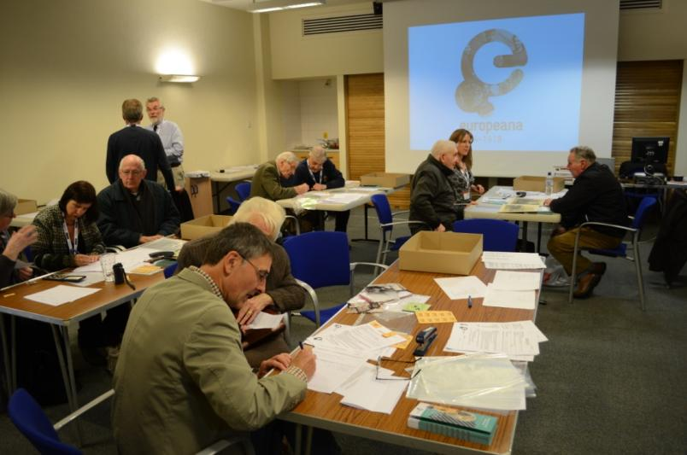
When you choose the venue for your event you want to consider a number of factors, such as:
Size and space
- Can you find a space for all required ‘stations’: Welcome, Interviews, Digitisation (incl. check-in/out, scanners, cameras), Public area, Staff and storage? The stations can be sections in one room or in different rooms;
- Is there enough room for staff, visitors, and equipment?
Location
Figure 1. A digital collection day at Banbury Museum
- Is it somewhere people will visit anyway or will want to visit?
- Is there room for people to wait and something for them to see/do while waiting (for example in a museum people can visit the exhibitions)?
- Is it easy to find and get to? Public transport? Parking?
- Can people with reduced mobility access it?
Does it have enough:
- power sockets;
- Internet connection (what do you need to access it? Is it fast enough? Can it handle heavy traffic?);
- tables and chairs;
- dividers of some kind –tables, screens, ropes (if you need to corner off one area);
- display cases/boards (if you need any);
- natural light;
- space to hold your equipment;
Access
- Can you have access before and after your event, to set up the equipment and do a test run and pack up afterwards?
Cost
- If the cost is high, can you do anything to get it down? Offer to promote the venue, co-organise with another event, shorten the time/choose another date? (Though consider carefully what any such arrangements mean for your event.)
Other questions to consider, and check with the venue, are:
- what venue staff will be available and when (may be needed to help you access various areas and equipment, for IT set-up, janitor duties, moving furniture, etc);
- arrangements for car parking on the day (staff and visitors) and when setting up and taking down;
- access to refreshments (for staff and visitors);
- do you need to safety check electrical equipment that you bring;
- safety regulations for the venue (is there a limit for how many people can be in one room? Do you need first aid staff on hand? Security staff?).
The guide Setting up the Venue contains suggestions for how to arrange your venue and what equipment you need in at each station.

Date and time
When choosing the date/time for your event, you need to think about a number of factors. Holding a Digital Collection Day during holidays or when all local schools are closed may reduce the number of people who are able to attend, or it may allow people who would otherwise be at work to participate. You may want to hold your event after building up momentum for public interest in the subject, for example after a series of lectures or an exhibition on local history or family history. Some timing considerations include:
- national holidays/ local public holidays;
- existing promotional events which can be added to like library reading weeks, an archives’ family history events;
- local market days;
- weekends or work days in a town with a commuting population;
- availability of venue.
When choosing the operating hours for the event, think about when people are likely to be able to attend (if on a weekday, participants in work may only be able to come early in the morning, at lunchtime or in the evening) and possible obstacles to attending at certain times (for example no parking during office hours, no public transport at weekends, etc.). Also consider your staff (when can they be expected to start and for how long can they work) and venue-related issues (opening hours, when you can start setting up, by what time do you have to have cleared up).
Ideally you want to set up and test your equipment the day before the event, at the latest. Consider doing a small test collection, for example with some invited contributors or friends of the project, to make sure staff know what to do and have had a chance to practice before the real event. After the event, you need time and staff to pack up and clear the venue. You also need time and staff to process the material and upload everything to the website. Ideally, you will set aside the day after the event for this and make sure staff (interviewers and media editors) are available as well as staff to wrap things up (answer queries, deal with extra visitors) and pack everything. If that is not possible, you must allow enough time before and after opening to the public to allow your staff to get ready.

Staffing
You need staff to interact with the public, record their stories, digitise, and add the digital material to the website. You also need staff to make sure all is running smoothly and solve any problems that may pop up during the event. You will also need staff to help after the event. How many people you need depends on the set-up of your event, your venue, and the number of visitors you are expecting. You normally need a team of at least ten to assist on the day (but many events have engaged and found use for a team of 30 or more).

Welcome Desk
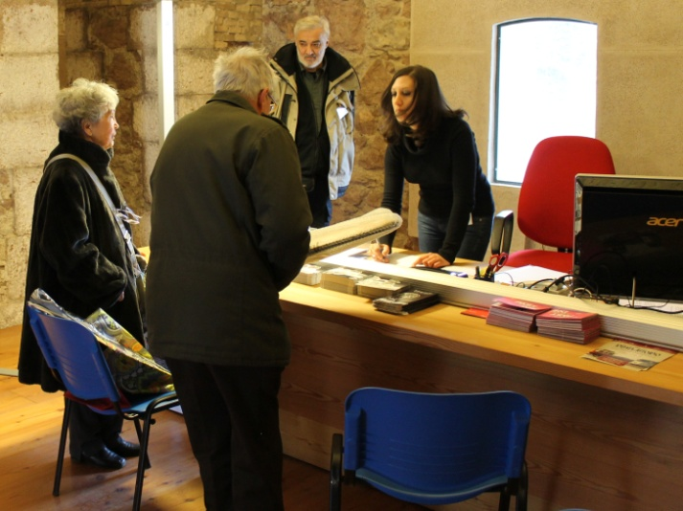
(more detailed information in the separate ‘Welcome Desk guide’)
The Welcome desk is the first thing visitors see when they arrive. At the Welcome Desk, staff introduce visitors to the event and related project (where applicable). Visitors that have objects or stories to contribute are told about the process and permissions and are given a copy of the permissions form to read and fill in before they are introduced to an interviewer.
At busy times, it may be necessary for people to wait for their interview. The Welcome Desk will help keep track of who is next and keep in touch with the staff managing the interview queue and the floor manager.
Figure 2 Receiving visitors at the Welcome Desk
‘Meet and greet’ staff will circulate in the waiting area ready to help visitors with the form, answer questions and make sure everything is running smoothly.

Welcome desk and meet & greet duties:
- make people feel welcome, whether they are contributing to the project or not;
- explain the relevant process (interview, digitisation) and that it may take time, clarify the permissions where needed;
- match up contributors with interviewers, if not done by dedicated interview queue staff (keeping track of who is in turn);
- help contributors fill in form while waiting for interviewer (if considered appropriate);
- work with the press desk and staff taking visitors to the interviews;
- be the central hub for communication and co-ordination.

Interviewers
(more detailed information in the separate ‘Interview station guide’)
If a visitor has a story and/or objects to contribute, they are paired up with an interviewer. The interviewer talks to the contributor about their object and story and records this information on a story form. They also document the objects that are to be digitised.
It’s recommended that two people work at each interview station, one to perform the interview while the other writes down the story. This can save time and be more natural (the interviewer can focus on the visitor instead of the computer screen), and ensure no information is lost.
Figure 3 With two people working at one interview station, one can take notes while the other interacts with the contributor.
When the interview is over, the interviewer (or assigned staff) takes the contributor and their object to the digitisation area (or takes contributor to waiting area, objects to digitisation) .I
Interviewers may also be involved in adding the stories to the website after the event (where applicable).

Interviewer duties:
- make the contributor feel they are welcome and that their contribution is valuable;
- ensure that the contributor understands the permissions asked for and is happy to share their story and object;
- find out about the object and related stories from the contributor;
- write the stories and key details on the story and object forms (computer or paper);
- if appropriate record the interview or part of as audio/video;
- potentially offer information about the objects or history to contributor;
- if applicable add the story and pictures to website (after event).

Digitisation
(more detailed information in the separate ‘Digitisation Station guide’
After the interview, the interviewer (or other member of staff) accompanies the contributor to the digitisation area where they leave their object for digitisation. Objects are photographed or scanned and then returned to their owner.
The Digitisation area has three main functions:
- Check-in. Objects placed in the ‘digitisation queue’ area.
- Digitisation. Objects are scanned or photographed and then placed in the ‘digitisation done’ area.
- Check-out. Objects returned to owner.

The work in the digitisation area is co-ordinated by a dedicated member of staff who keeps track of what is handed in and when, makes sure the material is processed and then returned to the owner.
Objects need to be kept safe at all times – no public access will be allowed to the objects while these are in the care of the event staff. As far as possible the objects should be handled and carried by their owners (for example from interview to digitisation).
The digitisation crew photograph or scan the objects. They may also be involved in processing the images afterwards (possibly after the event).
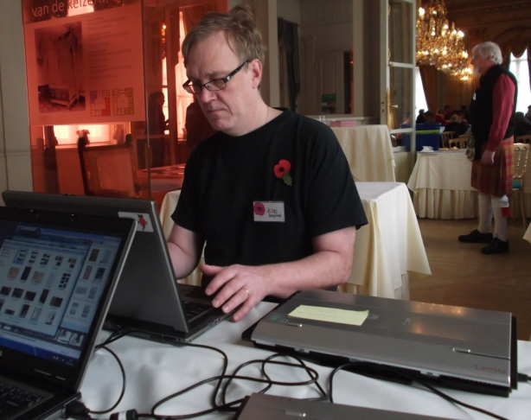
Digitisation equipment will be available at the event. However, photographers who have their own equipment which they are happy to bring and use are encouraged to do so.

Digitisation staff duties:
- fill in the ‘check in/check out list’ to keep track of objects
- digitise objects (photograph or scan);
- maintain the link to the contribution number (‘ticket’) in filenames and other processes;
- work with the rest of digitisation area staff to ensure queues are minimized, objects are captured effectively, and objects are safe at all times
Figure 5 Scanning
- potentially process the images and add to website (usually after event).

Equipment
On the day, you need to be able to record the stories people share, and digitise their objects. What equipment you need depends on how you run your event. You can, for example, record the stories on paper, on computer, or directly into an online form (where applicable). The former requires only pen and paper, for the latter you need computers and (for website access) a reliable Internet connection.
This list gives the main types of equipment you need. A more detailed description can be found in the Equipment check-list. The guide Setting up the venue also lists equipment needed for each station.

Interview equipment
- pens and paper
- computers with internet connection (optional)
- voice recorders for recording interviews as audio (optional)
- trays and folders for material to be carried and digitised (possibly)
- reference material (books, databases + project information) – may be provided or held by subject experts

Digitisation equipment
- scanner(s) attached to computer(s) with scanning software
- camera(s)
- good lighting
- copy-stand or tripods
- photography accessories, like memory cards, card reader, spare batteries, battery charger, spare light bulbs. equipment for displaying and holding objects (like book rests, weights), light cubes, reflectors, backdrops, etc.
- back-up solution for captured images (on server, stand-alone computer, external hard drive, or a combination)

Additional equipment
- computer(s) for/with:
  - welcome/registration desk (optional)
  - to access online reference resources/ for public browsing of website (optional)
  - internet connection to upload stories and images to website (can be done after event, or part during and part after)
  - image editing software for post-processing images (can be done after event)
- projector – to display slide show, films or other promotional material (optional)
- stationery – pens, paper, staplers, tickets, etc, for every station
- tables, chairs, etc
- paper forms, documentation, information material
- back-up solution for captured images and any digital documents created (server, stand-alone computer, external hard drive, or a combination) – may be part of digitisation equipment

Promoting your event
It is very important that information about your event is available and circulated widely if you want to have a good take-up. Think about what would be the most useful means for your target audience: posters and leaflets are the best way to reach certain groups of potential contributors, while other groups are better reached through social media. Local newspapers, radio, or TV coverage are other powerful ways to bring people to an event. If an event features in the news before it takes place, that usually encourages people to attend. Think about what message you want to convey to your audience, and do not hesitate to use a combination of methods to get varied coverage.
You may want to ask friends of staff and organisers to bring their objects and stories to the event. If they arrive first thing when you open, you will be able to start working immediately and you will have some stories and objects to show to interested press and visitors. Should the event be very busy from the start, ‘friends’ can be asked to come back later (or you process their material at your convenience). You may also want to bring some objects from your own collections that you can digitise should you have the time. This will not only mean that you have some potentially useful digital material but also that the digitisation station can start working at once before the first interviews are complete.

After the event
Running your event is a major achievement, but you should be aware that there will be work afterwards as well. This includes editing the images and stories you have gathered and dealing with enquiries. You need to make sure you have the staff and equipment to do this work. Ideally, interviewers and media editors should be available the day after the event to edit and process material.

Uploading stories and images
It is possible that stories (written on the Story Forms) will require editing before being uploaded onto the Lest We Forget website. It is usually easiest if this is done by the interviewers/note takers who recorded the story at the event, and preferably very soon after the event.
During the event a large number of images will have been taken. Afterwards you have to identify which images go with what story and process them to ensure they are suitable for online delivery (where relevant).

Dealing with enquires
You are likely to be contacted after the event and demands will be put on your time. You need to prepare for this and decide how you will deal with queries from, for example:
- someone who could not attend the event and now wants to contribute;
- someone who attended the event and now wants to add/change something;
- someone asking for (high-resolution) copies of images or more details about a story (usually press/media);
- press and media. They may want to interview you or, usually, one of the contributors.

More information and Next Steps
If you and your organisation would like further information on how to run your own ‘Digital Collection Day’, and/or would like to begin the process, please contact The Lest We Forget Team via our website: https://lwf.web.ox.ac.uk via email: ww1collections@it.ox.ac.uk or via Facebook: www.facebook.com/OxfordLWF/
We will be delighted to provide you with:
- A detailed ‘TRAINING PACK’, including all the information you need to run a ‘Digital Collection Day’ (guides, check-lists, template forms, promotion material, etc)
- Tailored advice, creative ideas, and ongoing support for running your own fantastic event

We Look Forward to Hearing From You

The Lest We Forget Team would like to sincerely THANK YOU for your interest in organizing a ‘Digital Collection Day’. With your help, we can save the memories, stories, and objects of the First World War for future generations.

